Questions 1 - 10

Questions 1 – 7
Complete the table below. Write ONE WORD AND/OR A NUMBER for each answer.
FESTIVAL EVENTS
Event | Cost | Venue | Notes
Jazz band | Tickets available for £15 | The [1] school | Also appearing: Carolyn Hart (plays the [2])
Duck races | £1 per duck | Start behind the [3] | Prize: tickets for [4] held at the end of the festival.  Ducks can be bought in the [5]
Flower show | Free | [6] Hall | Prizes presented at 5 pm by a well-known [7]

Questions 8 – 10

PLAYS
Who is each play suitable for? Write the correct letter A, B or C next to questions 8–10.
Amainly for childrenBmainly for adultsCsuitable for people of all ages
8.The Mystery of Muldoon
9.Fire and Flood
10.Silly Sailor

Questions 11 - 20

Questions 11 – 16

MUSEUM COLLECTIONS
What does the speaker say about each of the following collections? Choose SIX answers from the box and write the correct letter A–G next to questions 11–16.
Awas given by one personBwas recently publicised in the mediaCincludes some items given by members of the publicDincludes some items given by the artistsEincludes the most popular exhibits in the museumFis the largest of its kind in the countryGhas had some of its contents relocated
11.20th- and 21st-century paintings
12.19th-century paintings
13.Sculptures
14.'Around the world' exhibition
15.Coins
16.Porcelain and glass

Questions 17 – 20

MUSEUM PLAN
Label the plan below. Write the correct letter A–H next to questions 17–20.
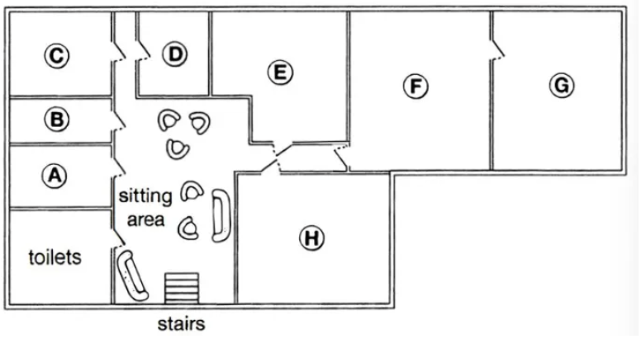

A A B B C C D D E E F F G G H H
17.restaurant
18.café
19.baby-changing facilities
20.cloakroom

Questions 21 - 30

Questions 21 – 22
Choose TWO letters A–E.
21–22Which TWO characteristics were shared by the subjects of Joanna's psychology study?
A.They had all won prizes for their music.B.They had all made music recordings.C.They were all under 27 years old.D.They had all toured internationally.E.They all played a string instrument.

Questions 23 – 24
Choose TWO letters A–E.
23–24Which TWO points does Joanna make about her use of telephone interviews?
A.It meant rich data could be collected.B.It allowed the involvement of top performers.C.It led to a stressful atmosphere at times.D.It meant interview times had to be limited.E.It caused some technical problems.

Questions 25 – 26
Choose TWO letters A–E.
25–26Which TWO topics did Joanna originally intend to investigate in her research?
A.regulations concerning concert dressB.audience reactions to the dress of performersC.changes in performer attitudes to concert dressD.how choice of dress relates to performer rolesE.links between musical instrument and dress choice

Questions 27 – 30
Choose the correct letter A, B or C.
27.Joanna concentrated on women performers because
A.women are more influenced by fashion.B.women's dress has led to more controversy.C.women's code of dress is less strict than men's.
28.Mike Frost's article suggests that in popular music, women's dress is affected by
A.their wish to be taken seriously.B.their tendency to copy each other.C.their reaction to the masculine nature of the music.
29.What did Joanna's subjects say about the audience at a performance?
A.The musicians' choice of clothing is linked to respect for the audience.B.The clothing should not distract the audience from the music.C.The audience should make the effort to dress appropriately.
30.According to the speakers, musicians could learn from sports scientists about
A.the importance of clothing for physical freedom.B.the part played by clothing in improving performance.C.the way clothing may protect against physical injury.

Questions 31 - 40
Complete the notes below. Write ONE WORD ONLY for each answer.
THE USE OF SOIL TO REDUCE CO₂ IN THE ATMOSPHERE
Rattan Lal:
● Claims that 13% of CO₂ in the atmosphere could be absorbed by agricultural soils
● Erosion is more likely in soil that is [31]
● Lal found soil in Africa that was very [32]
● It was suggested that carbon from soil was entering the atmosphere
Soil and carbon:
● plants turn CO₂ from the air into carbon-based substances such as [33]
● some CO₂ moves from the [34] of plants to microbes in the soil
● carbon was lost from the soil when agriculture was invented
Regenerative agriculture:
● uses established practices to make sure soil remains fertile and [35]
● e.g. through year-round planting and increasing the [36] of plants that are grown
California study:
● taking place on a big [37] farm
● uses compost made from waste from agriculture and [38]
Australia study:
● aims to increase soil carbon by using [39] that are always green
Future developments may include:
● reducing the amount of fertilizer used in farming
● giving farmers [40] for carbon storage, as well as their produce

